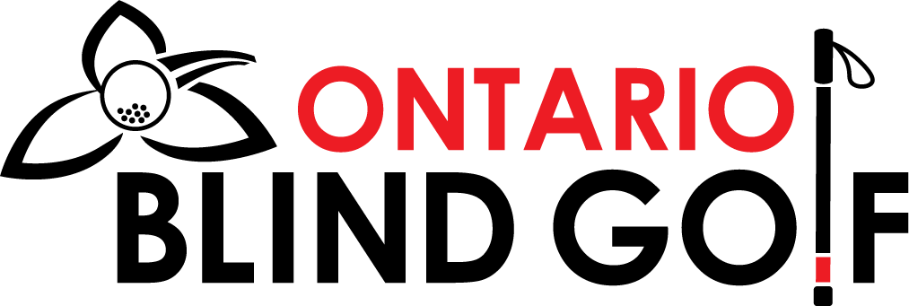

2026 Ontario Blind Golf (OBG) Registration Form

Please return the Registration Form and payment no later than March 7, 2026

By mail, including cheques, please send to:
Brian and Deanna Morgan
280 Rolling Meadows Drive
Kitchener, ON N2N 2V4

By Email to:
bmorgs62@gmail.com
Payment by cheque, please make out to Ontario Blind Golf

If payment is made by E-transfer, please make sure to include your name in the Notes section. Transfer to our Treasurer, Wayne Cook at: OntarioBlindGolf@gmail.com

Please complete and return pages 3, 4 and 5 of the Registration Form.

The Annual Membership Fee for 2026 is $75 for all blind or vision impaired golfers. More than a great deal for all members, not only for the events we host, but the expenses we cover to make this all possible.
Early Bird Special: If you pay for your membership by March 7, your name will be entered into a draw for a free cart ($30 value) at one of our 2026 events.
As always, by paying your membership dues you automatically become a member of OBG and Blind Golf Canada (BGC). All members will need to decide if they want to play as a recreational or a competitive golfer.
*Please note - ALL competitive golfers are required to maintain a handicap. Competitive members can use the handicap services of Golf Canada and can also enjoy several other benefits for being a Golf Canada member.
- Cart fees for the year will increase slightly to $30 per event
- There are no costs/fees that the Guides have to pay
- Charitable tax receipt will be issued for donations above $20
- Please confirm if you want Golf Canada membership, else we will assume you are playing recreational

We thank you in advance for any donations and count on any additional support you can provide to help support our organization. This can be through financial contributions by yourself, family members, friends or any potential sponsors you know.
If you would like a letter that you would share with a potential sponsor, please contact Dino Beltsis at: kostantino@rogers.com
We will be hosting a Zoom call for OBG members on April 15th. We will draw for the winners of the cart rental on that call.

2026 OBG Registration Form

Name: ______________________________________________

Street Address: ______________________________________

Postal Code: ________________________

City: _____________________

Telephone: ________________

Email Address: _____________________________________

Birth Date: ______________________________

CNIB Number: _______________________________________

Sight Classification:
- B1
- B2
- B3
- B4
- Not Sure

- Recreational
- Competitive

Please note:
All blind golfers need to be members of CNIB and have a CNIB card and Membership Number.
All blind golfers are encouraged to have their eye specialist complete an International Blind Golf (IBGA) Sight Form to get their sight classification. If you feel your sight has deteriorated and your sight category has changed, you should complete a new form.
To play competitively in any event you must have a sight form completed and submitted to Hugh Montgomery at hugh.montgomery@bell.net

Payment Details
Annual Membership Fee: $75.00
Charitable contribution: $_____
Total Amount enclosed: $_____
Please make all cheques payable to: Ontario Blind Golf
E-transfer OBG at: OntarioBlindGolf@gmail.com (please include your name in the Notes)

Guide/Coach Information

We require your Guide’s name. If you have a regular Guide(s) that you use, please include his/her information below. Please ensure you have permission to do so.

Guide’s Name: _______________________________________

Guide’s Email: _______________________________________

Guide’s Phone #: _____________________________________

Guide’s Name: _______________________________________

Guide’s Email: _______________________________________

Guide’s Phone #: _____________________________________

AUTHORIZATION FOR SOCIAL & PRINT MEDIA PUBLICATIONS
I, _____________________________, the undersigned, grant permission to OBG and Blind Golf Canada to take pictures/videos of myself participating at any/all blind golf events. Further, I grant permission to allow OBG and BGC to share/post/publish any/all photos of myself in all social and print media publications. I will also provide any/all photos/videos to OBG and Blind Golf Canada at their request to share in all publications.
Member Signature: ___________________________________
Date: ____________________

Do you have any questions, ideas or feedback for the OBG Board as we continue to plan for the 2026 season and beyond?
____________________________________________________________
____________________________________________________________
____________________________________________________________

Thank you from your 2026 OBG Board of Directors:
Rick Kush, Hugh Montgomery, Dino Beltsis, Brian & Deanna Morgan

Please return pages 3, 4, and 5 as well as your payment by March 7

